CLIMBING GYM “SLEEPING ELEPHANTS” – experience empowerment of disabled children and involve local community to active and rich leisure time!

Project dates: 01/08/2017 – 30/07/2018
Place: Kaunas, Lithuania
Topic: people with disabilities; people with less opportunities 3 volunteers in the center.
Application deadline: 20th January 2017 to sinfo@miegantysdrambliai.lt

Please see more at our FB profile: https://www.facebook.com/vsimiegantysdrambliai?fref=ts Read more adventures of our volunteers in various projects: http://timetoevs.blogspot.com/

About the host organization – “Sleeping Elephants”

“Miegantys Drambliai” (Sleeping Elephants) is a non-governmental, non-profit organization promoting active and healthy life-style, mainly known for climbing sports in Lithuania, collaborating with other non- governmental organizations all over the country, implementing active leisure events together. Climbing sport is developing in Lithuania, which makes it interesting to work with. Last year our club was chosen to lead the National Climbing Sports Association for the two years of presidency.

“Miegantys Drambliai” organisation is situated in a climbing centre, so one of the aims is to offer sports education through climbing and outdoor activities (regardless of age or physical experience), canistherapy (work with dogs) and social events. Our main goals are about building stronger sports and leisure communities in the city and abroad, involving all generations and socially disadvantaged people: children, parents and grandparents, disabled children and local youngsters from social risk families. We use non-formal education methods, we teach mostly during the activities and practice in the organisation, sharing everyone's knowledge daily.
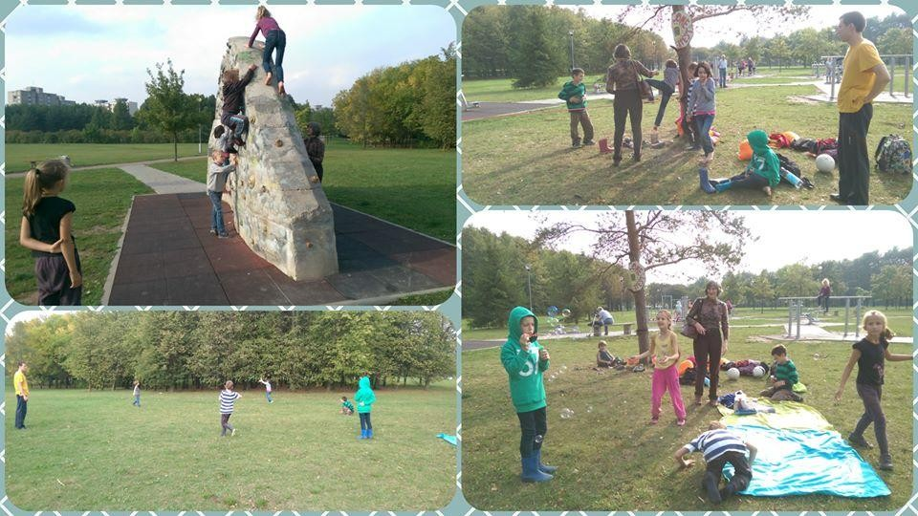

Environment

“Miegantys Drambliai” is the club in Kaunas representing Lithuanian Climbing Sports Association. It is supported by one of the most modern and safe climbing gyms in Lithuania. We are a reliable organization, working for 8 years already, well known in the city.
We are situated in Kaunas, the second largest city in Lithuania, after the capital Vilnius, with a population of ~300.000 people.

The Lithuanian social context: the country is in continuous improvement and is living big changing times. Thanks to its early independence, just 25 years ago, a totally new approach to business has been followed, focusing on the importance of progress and building new activities. The result is a modernization in every field, from infrastructures to social and ecologic awareness.

We are trying to promote climbing in a country with no mountains, thing that makes our mission more challenging, but beautiful at the same time. We were functioning with two gyms for the last 6 years, in an old radio factory, until we decided to move to a bigger and more comfortable facility. Now we have the perfect space, where in summer, the sun will shine on the back of our climbers - detail very important after the long winters. We have already experience and methods to work with disabled children and youth through the Paraclimbing project. We also have more space for offices and resting/workshop zones.

We're permanently trying to enlarge our community and to make climbing open to everyone, reason that convinced us to build an outdoor boulder-stone in the first place. We invite children from social risk environments and complex disabilities in our gym and we try to involve also parents, grandparents, friends, neighbours, locals and internationals.
We don't limit our presence to the indoor climbing gym, but we go in schools and speak about climbing, inviting kids and teachers to explore this activity; we organise international climbing camps with a learning process; All our team is open-minded and ready to welcome new members, helping them integrate immediately in our beautiful diversity.

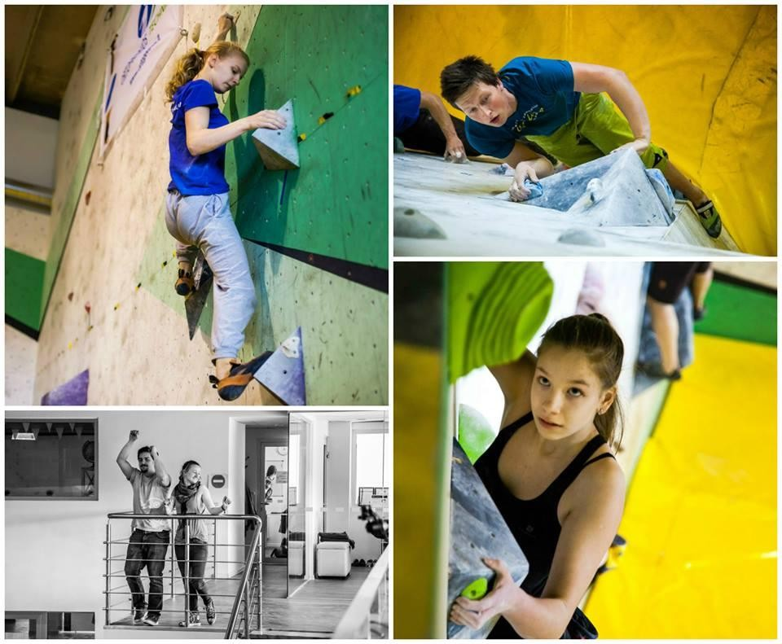

Role and tasks of the volunteer at Sleeping Elephants

This is how the integration process of the volunteer will look like:
- First they will observe and will be exposed/experience to all the work our staff is doing (1-2 months).
- They will take part in organizing sport activities, so they can apply everything they saw (2 months).
- Volunteers will coordinate sport activities and other related projects, fulfilling the learning process (2 months).
- They can pay it forward by teaching others what they have learned in their first six months (6 months) CLIMBING ACTIVITIES like: 1. Assistance to the sport coach during trainings, updating sports team database (training schedules, attendance, ect.) helping to the sports team members to fill in their individual sport diaries; creating climbing routes, screwing grips, cleaning gym; going once a week in the local park where we have built a climbing stone and introducing climbing to local people;
Writing monthly reports for documentation, making statistics and accomplishments diagrams, preparing monthly presentation for the general meeting; Sport climbing trips and camps on natural rocks for sportsmen.
- Assistance to the sport coach during competitions: helping to prepare team for the competition, registering needed documents, organizing the trip and leisure activities; Motivating and supporting the sportsmen, solving emotional problems during competition; Taking photos and editing, writing reports after competitions and sharing (via FB sports team group, club website, email group); Printing competition results, exposing it on the sportsmen news-board, discussing results with them;

- Presenting and promoting climbing all around Kaunas: Going in schools and social centres and organizing workshops where a short movie, the climbing gear, techniques and safety rules are presented; inviting them into our gym for further practice

COMMUNITY BUILDING ACTIVITIES like:
1. Organizing events: Monday evenings with movies and presentations about climbing, travelling; “Laipiojimo akmens festivalis” – “Boulderfest” and “Draugystės parko festivalis“ - culture animation project every Wednesday and Thursday (and more) in the park for community building; “Boulderingas” climbing promotion events for amateurs; Various eco-workshops and handcrafts; Various celebrations Mother‘s Day, Father‘s Day, Kids Day, birthdays, ect.

SOCIAL WORK ACTIVITIES like:
- Help for those in need when needed:
Social and other help for sportsmen with fewer opportunities during and after the trainings (listen to their needs, identifying problems, supporting them, help with homework, ect.);
“Laipiojimo akmens festivalis” – “Boulderfest” and “Draugystės parko festivalis“ - every Wednesday and Thursday (and more) in the park reaching the people with less opportunities and helping them through non-formal and social-animating activities;
Paraclimbing – volunteer will have to work a lot with disabled children or youngsters, usually providing individual assistance while climbing, maintaining motivation, and personalising the trainings to the specific traits of the participants. Most likely we will add/promote social field for self-empowering parents groups and camps, also providing social support with collaboration of local social NGO for disabled families “Socactiva”.
Canistherapy – it is new activity in “Miegantys drambliai” that was already practised 6 months. Trainers with dogs work with disabled children and youngsters, also with other kids, who has emotional and social problems and learns create safe and trustful relation. Canistherapy is new method of work with different problems, trainers go to schools, different social centres, so volunteers will be included to this work together.
Climb your top – project for children from social risk environment or disabled. Bringing them into the gym through a 5 steps program:
- First pre-visit to the centre, getting to know the kids, getting involved in their routine; presenting project to social workers;
- Second pre-visit to the centre, helping kids with daily tasks, playing games, starting to talk about volunteering and MD;
- Opening-session: presenting climbing in the centre: short movie, gear, warming-up games. d). Kids visiting the gym: applying what they saw/ learnt in the introduction round; climbing. e). Closing-session: outdoor activity, language lesson, eco-workshops.
- Promoting voluntary work in Kaunas and Lithuania: working with new volunteers, explaining the idea of voluntary work in everyday activities, teambuilding, teaching each others, supporting; visiting schools and explaining what/ volunteers do;

- Building climbing walls for schools and social centres.

HEALTHY LIFESTYLE AND GREEN-OUTDOOR ACTIVITIES like: Collecting news about active, healthy lifestyle, nature conservation, green-living from all over the world. Supervision of our clubs Green corner and PABUSK (wake-up) facebook page, sportsmen group; preparing/joining one day duration programs/initiatives in Kaunas - healthy lifestyle for kids and elderly people and taking part in them; organizing educational events/field trips to nature by feet/bike for the local community. Looking for environmentally friendly places, finding routes and locations for trips; organizing PABUSK (wake-up) events about conscious lifestyle: alcohol and tobacco harm, fast-food damage; Eco-outdoor and health

camps in nature, in Lithuania. Looking for environmentally friendly places, finding routes and locations for trips, creating programs, looking for games, green activities.

By the time our volunteer’s project will end, they will be skilled in the MENTIONED areas and even more.

Volunteers’ profile

- We would prefer volunteers who are familiar with outdoor or indoor sports, practicing it or who are physically strong. We also welcome volunteers who are not familiar with climbing sport yet, but would like to know more and try it out, to practice and assist other people, who would like to join activities of our organization;
- People who would like to communicate with kids, youngsters or adults every day;
- We welcome volunteers who are not afraid to encounter problematic youth, who would be interested to support them in solving their problems;
- Our organization will welcome people who are willing to learn every day, who wants to become flexible and tolerant;
- We prefer volunteers who don't have a problem with sudden changes in schedule and who don't like having the same routine every day.

RECRUITMENT
For a transparent recruitment process, first we send a set of questions to the applicants that test their way of thinking (about Lithuania, about being on their own, about their readiness). Also, we ask for some photos from their daily life, to better understand their background and lifestyle. Also, we introduce project information with tasks given in advance and make sure they understand what exactly they will do.
Second, for those who replied and still interested, we send a list of tasks that our three present EVS-es are doing and ask applicants where do they see themselves more. Here they also can ask questions and communicate with present volunteers.
Third we plan on having several Skype interviews with some chosen candidates, to get to know them beyond their motivational letters and show our team live.
We believe this system allows all young people to apply for a volunteering spot, regardless of race, nationality, religion or political views, as long as they find themselves in the list above.

PRACTICAL ARRANGMENTS
Coordinating organization "A.C. Patria" will assure a room in a flat or house for each volunteer that “Miegantys Drambliai” will select, with all the utilities paid. Also, each volunteer will have a monthly ticket for all the Kaunas public transportation routes and pocket money.

Our club is at just a few bus stations away from the centre and a few stations from a forest perfect for outdoor activities. The park is in front of our office. We will provide a desk for volunteers in the office, which will be a personal working space during EVS time. All needed equipment will be given.

First two months will be for observing how things are happening in organization and helping with the little easy tasks, starting to participate in projects. The volunteers will meet each member of the staff - who does what and will be introduced to all the gym areas (from offices to counter and first aid kit).

Each volunteer will have one mentor and one tutor, who will provide weekly/ monthly meetings for them, depending on the needs or problems, also will provide evaluation periodically. All staff will help with the integration and learning process.

Our organization is working due to Quality Guide for EVS program and actively participates in group meetings with other EVS hosting organisations in Lithuania. We are also in a close cooperation with our coordinating organisations, to keep track of the quality of the project for the volunteers.

Sports in our Bouldering Gym are dangerous not more than other sport, because the walls are not higher than four meters and the ground is covered with mattresses. Also volunteer will be introduced to the safety rules in the gym and prepared to work safely.

During first two months, every week, the volunteer will meet mentor and tutor, and together they will set the tasks for the week, will reflect on the accomplished ones. They will discuss the difficulties experienced and search for possible solutions. One of our workers has experience with youth coming from social risk environment, knowledge of psychology, therefore is able to observe changes in volunteers emotional state and provide support if needed. Friendly staff will be around all the time.

Please see more at our FB profile: https://www.facebook.com/vsimiegantysdrambliai?fref=ts Read more adventures of our volunteers in various projects: http://timetoevs.blogspot.com/

